THEME 2: Identifying Target Audience

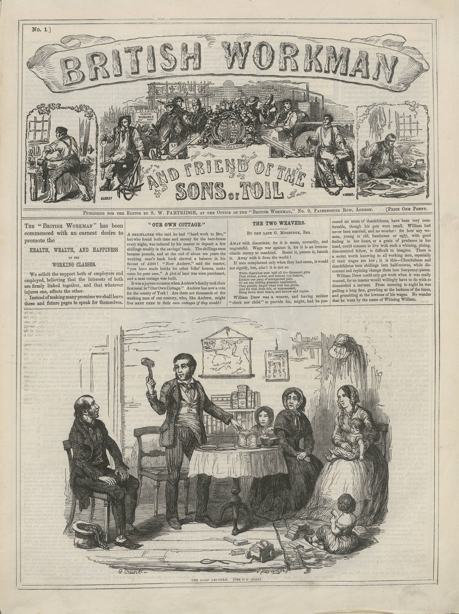

British Workman A

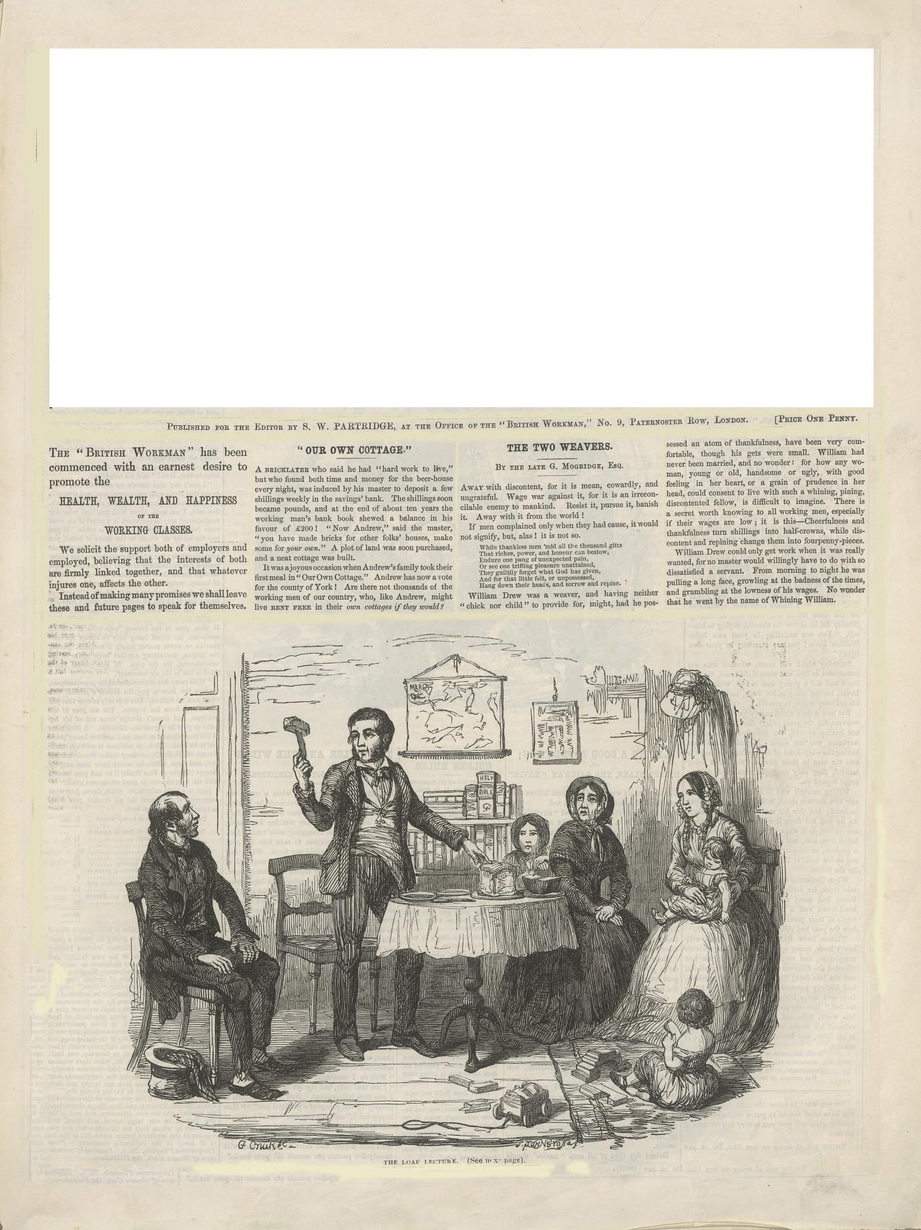

British Workman and
Friend of the Sons of Toil
British Workman B

Introduction
What we want you to get out of this session
- Think about how layout on a page (or screen) affect how you might understand or use the page
- Improve your understanding of how images work
- Think about how they interact with words
- Learn about how to target an audiences
The British Workman was a cheap monthly paper that came out first in 1855. This is its first issue.
- Compare the two versions (British Workman A and B) of the front page of the first issue of the British Workman and Friends of the Sons of Toil. What are the similarities and differences?
- Which one is easier to read? Why?
- Compare the two mastheads: what do you think each is trying to tell you?
- Which version do you think is the original? Why?

Reading the Page: “Mirror, Mirror on the Wall…”
Now look carefully at the masthead on page 5.
- Which of the following jobs can you see (make sure you look at the background too!)?
Tailor/ Farmer/ sewage worker/ nurse/ doctor/ carpenter/ builder/ road mender/ sailor/ soldier/ office worker/ bricklayer/ billboard sticker/ shop assistant/ teacher/ carriage driver
- What can you see in the background? How do you think the background connects to the jobs?
- How do you think one of the jobs in the background connects to the paper itself?
- How many women can you see? What does that tell you about how the Victorians thought of “work”?
A target audience is the kind of person we are thinking of when we write something. We all have target audiences – you have one even when you write your essays at school. It’s the person in our heads we want to communicate to. Mastheads are used by newspapers and magazines to tell readers if they are the target audience or not.
- What kind of person is the target audience of the British Workman?
- Now look carefully at the letters of the title on the masthead. What is it supposed to look like? Metal/ Wood/type / flowers/ animals/ people?
- So who do you think the imagined readers are supposed to believe made the paper? Is it someone pictured in the rest of the masthead or someone else? Is it someone like them or someone very different from them?
Now think about when you take advice: do you listen to someone you think is “on your side” and can imagine what it’s like to be you, or someone who Is only concerned with themselves?
- So why is the title made to look like the way it is?

- Now go back to comparing version A and B of the whole front page. Why do you think the lines around the edge of the page and between the columns and sections are there in version A?
Printers call such lines “rules.” Which of the following possible explanations are most convincing do you think? Why? You may decide none or all of them are convincing.
- The lines frame the page so you can tell when bits have been ripped out or cut off
- The lines make the page easier to read by making the sections stand out
- They make the page look more like a newspaper and so more authoritative
- The lines make you understand the page in a certain way – they “give you the rules” of how to understand the page as a whole
- They cut the words and pictures off from the world around it and so let you “escape” into the page away from the world more easily
Which of the above explanations most corresponds to the kind of target audience you have discovered for the British Workman?
- Finally, what magazines covers or website or app splash screens do you know from today? Can you tell the target audience from looking at them?

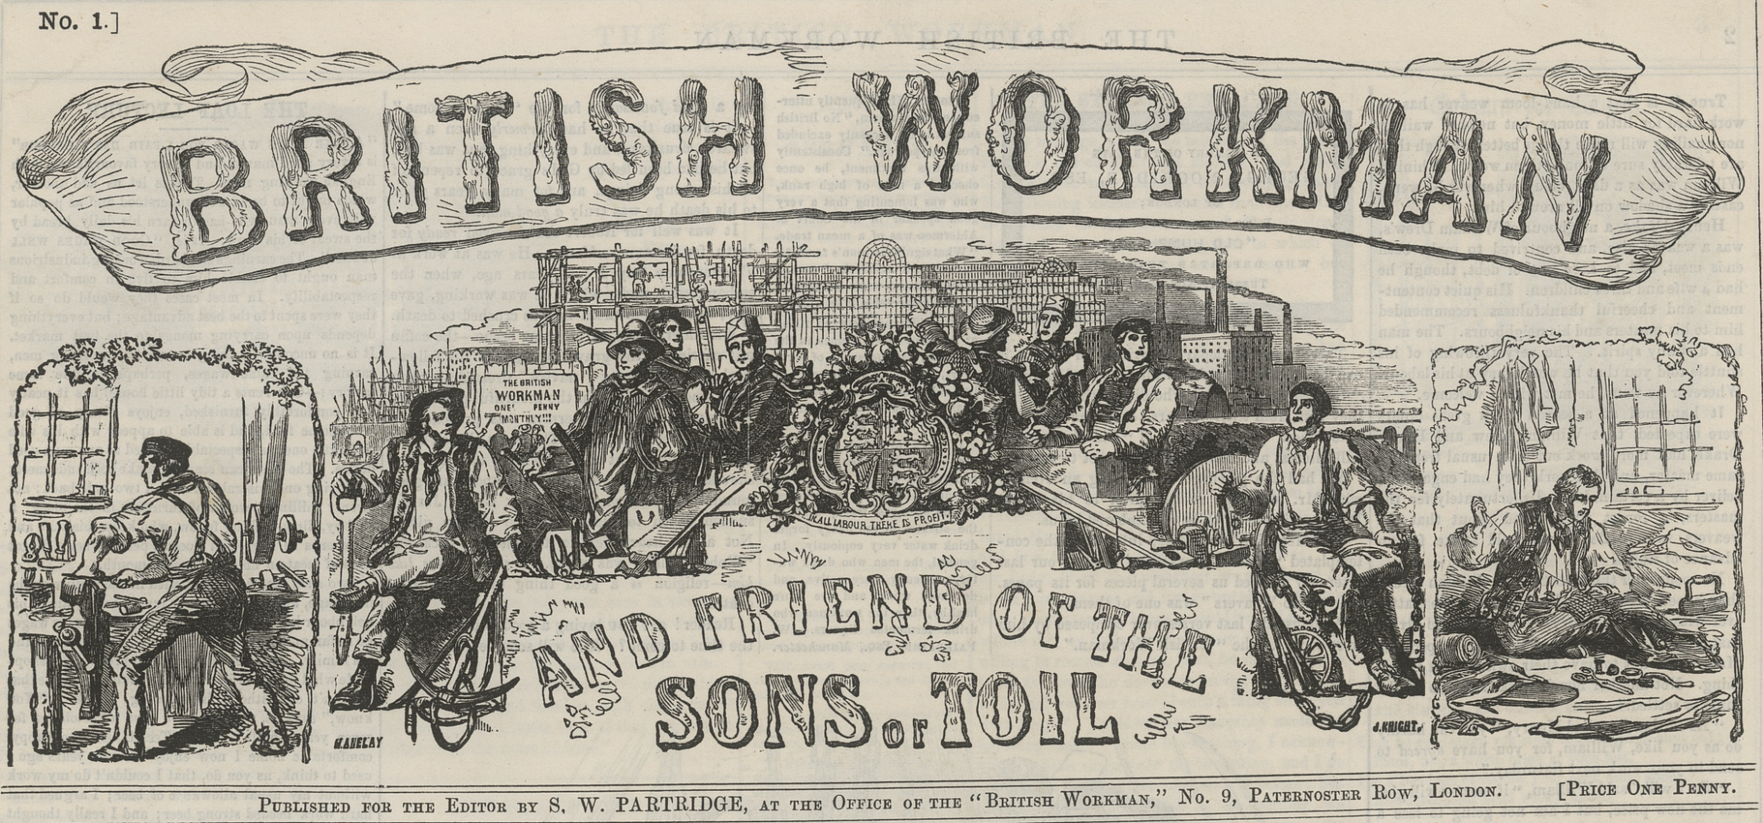
Section 2: The obedient reader
Which of the following words best describes someone who follows instructions?
    - naughty
    - wilful
    - obedient
    - creative
    - kind
    - cruel
Look at the illustration on the next page. List all the items you can see in the room.
- Can you tell what kind of room it is?
- Who do you think all the characters are? (a clue, the man on the left is a guest)
- Given that it shows a group in 1856, what kind of people do you think are they? How do you know?
Young spendthrifts/ a hard-working family/ religious people/ uneducated people
- Now think about what you learned about how mastheads select the kind of readers the publication wants – the target audience. Can you tell who the main target audience is in this picture? How do you know?

- Can you tell what’s happening in the picture?
- What’s on the table?
- What’s on the man’s knife?
If you aren’t entirely sure what’s happening, that’s what the picture wants you to feel!
Now read the caption again and think:
- Why does the caption say “See next page”?
Clues
  - If you saw the British Workman in a Victorian shop, it would be in a shop window or behind the shop counter. If you wanted to see the next page you’d have to ask the shopkeeper to let you. What would you have to do to get the shopkeeper to allow you to see it?
  - If you do want to turn over the page, it means you are obeying an instruction that the paper is giving you. What kind of relationship does that mean you have to the magazine? If now you know what kind of person the main target audience is, what kind of people do you think indirect target audiences are?

- Why would it be good for the paper to have both main and indirect target audiences?
Write down 2 things you have learned about how newspapers communicate from this session.

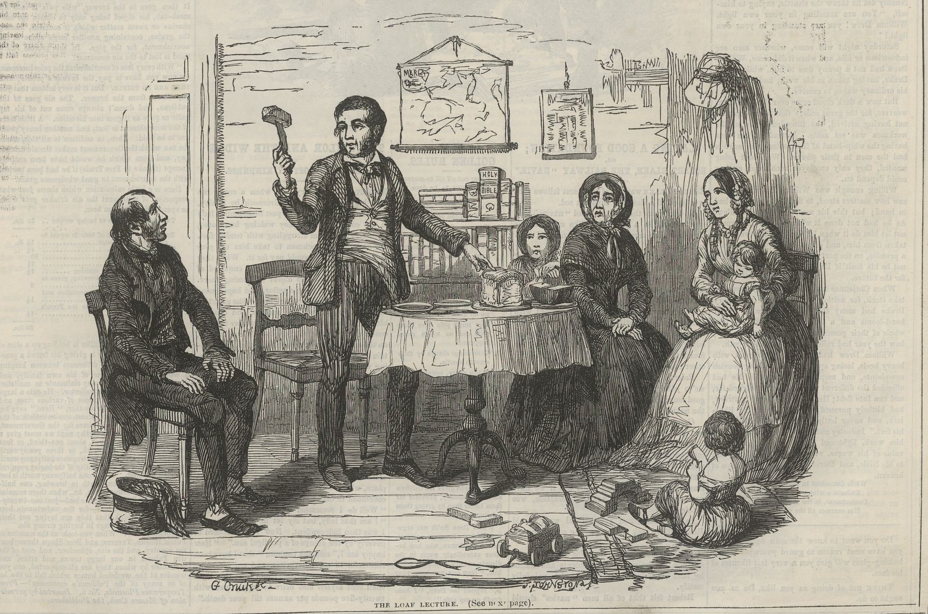
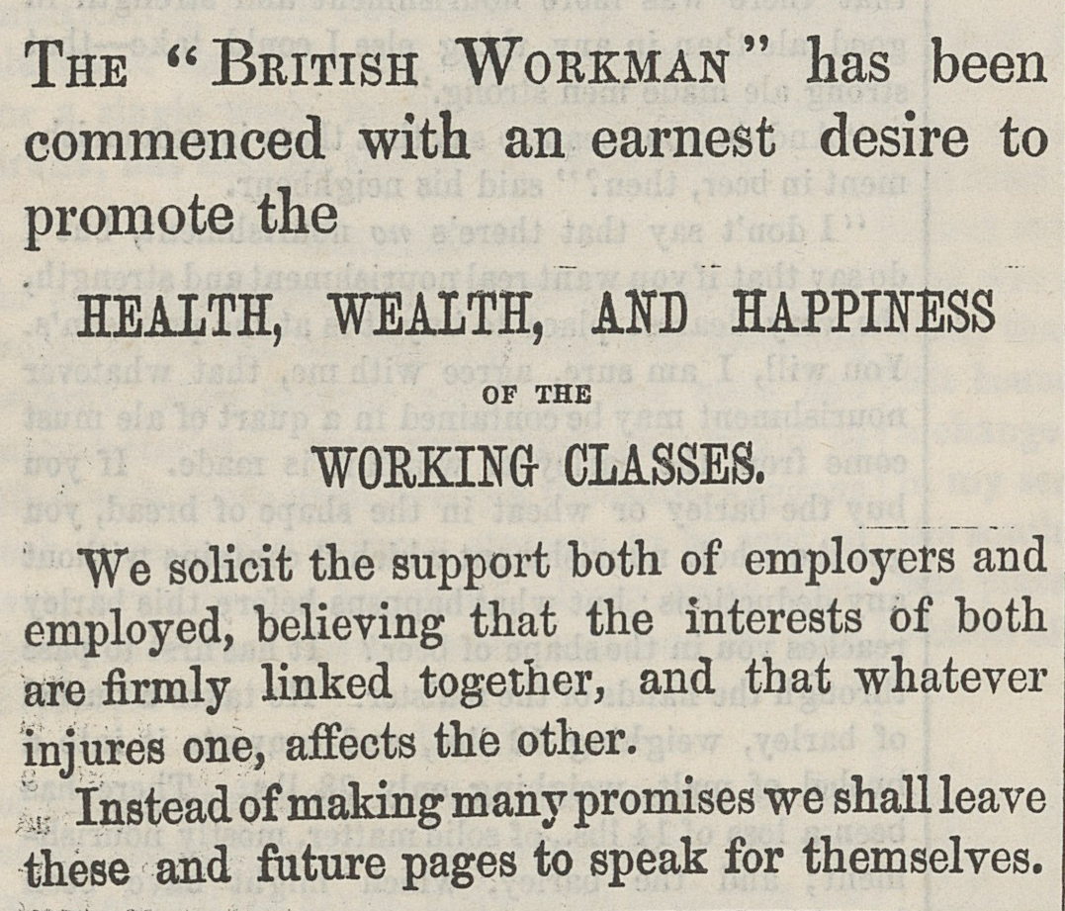
STYLE AND THE INTENDED AUDIENCE
Read the passage above and compare it to the following version of the same:
We’ve begun this magazine because we want you to be healthy, rich and happy!
You and your employers are on the same side: we all need to work together!
We shan’t say any more now: just read us and find out!

The two passages mean almost the same thing but they address two different types of reader – two different kinds of target audience. To help decide exactly what the target audiences are, think about questions like these:
- Which passage has more personal pronouns?
- What kind of vocabulary is used in each?
- Which one has the longer sentences?
- Which uses active and passive verbs?
- What’s the difference in punctuation and what effect does this have?

THE EDITORIAL LINE
Magazines often have what’s called an editorial line. The editorial line comprises a set of rules about what the magazine thinks its target audience is like.

Group 1
Read the following story from the first page of the British Workman and try to decide what the editorial line is as regards work, savings, and beer drinking!
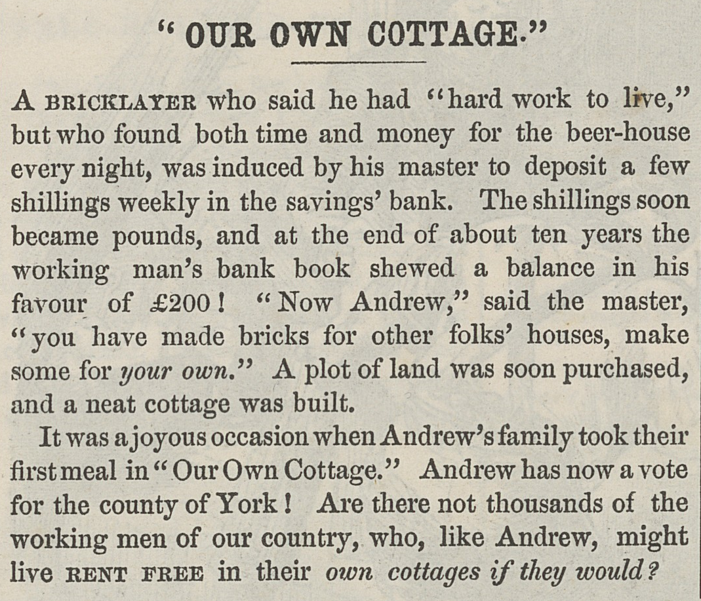
Work _____________________________________________________________________
Saving_____________________________________________________________________
Beer drinking _______________________________________________________________

Questions to consider you might not have thought of:
- Who – according to the story – knows what the story tells us is the best thing to do to make the bricklayer healthy, wealthy and happy?
- Who tells us what the bricklayer’s name is?
“The shillings soon became pounds, and at the end of about ten years the working man’s bank book showed a balance of £200!”
- What is the subject of that sentence? Which one suggests magic? Compare it with the following and explain the differences:
“Andrew scrimped and saved, drank only water and didn’t buy toys for his children or new clothes for his wife and himself. The children went out to work when they were eight years old. After ten years, Andrew had saved enough to buy a plot of land where he could build a house.”
Have you any clearer idea of what the magazine’s editorial line might be from reading this story?
Now rewrite the story, using the same number of words – about 150) either from the point of view of the workman OR from the point of view of the workman’s wife OR one of this children. You don’t need to be an “obedient reader” of the original story – though you might want to be!
Now elect a speaker who will report back to the rest of the class what you’ve found out about the editorial line of the British Workman.

Group 2
Read the following story and try to decide what the editorial line is as regards work, savings, and beer drinking!
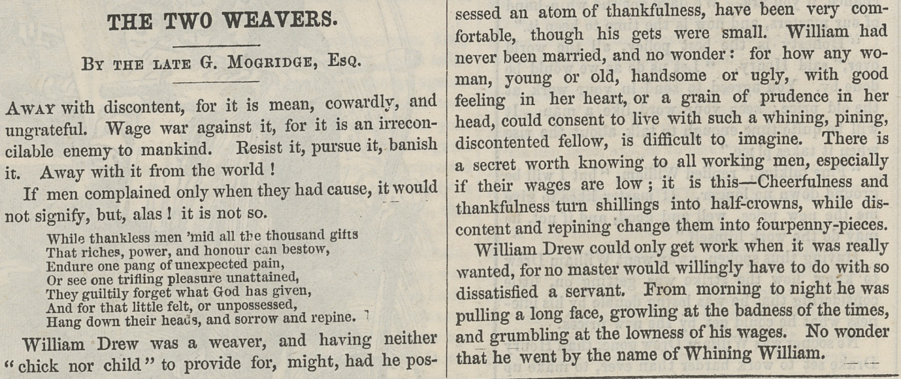

About BLT19

BLT19 (Nineteenth-Century Business, Labour, Temperance, & Trade Periodicals) is a University of Greenwich pilot project aimed at encouraging students and educators to access and engage with digitised nineteenth-century periodicals. BLT19 materials for educators are available at www.blt19.org. Questions about the project or teaching materials can be directed to blt19@blt19.org.

